Operations with Integers using Manipulatives

Using manipulatives allows a teacher to introduce topics in a conceptual manner rather than focusing on procedures. Teaching methods allowing a transition can include the following stages:
- Direct modeling
Topic taught is not used at this stage. Manipulatives allow students to focus on developing
Generalizations using counting techniques.
- Pattern development
Students use informal methods to complete the requested tasks. They do not use formal procedures to explain their work. Many teachers call this stage the “Ah ha, I see what’s happening.” time for students. Students are encouraged to explain the patterns they see both verbally and in writing.
- Traditional algorithm
Teachers use this stage to introduce algorithms. Remember, stages 1 and 2 and based on counting skills which are less efficient than algorithms regarding the time needed to complete a task.

Two-color counters provide a useful way to introduce operations on integers to students of all ages. Two-color counters help to develop concepts related to integers, algebraic expressions, equations, and polynomials. Point out that small yellow tiles (+1 tiles) are used for positive integers and small red tiles (–1 tiles) are used for negative integers.

Since the sum of a number and its opposite is zero, together, a positive tile and a negative tile represent zero and are called a zero pair. Use your counters to model a zero pair on the overhead projector.

Key: | 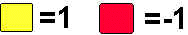

*Be sure to stress that a red tile and a yellow tile will add to 0 and will be removed from the table.

Integer Operations

Addition: Show 3 + ( -5 ) = -2
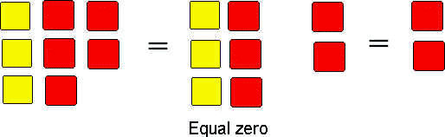
Copyright ©1999-2003 Oswego City School District Regents Exam Prep Center

Subtraction: Show 5 - ( -2 ) = 7
The concept of "subtraction" is the removal of a certain number of tiles. In this problem it is necessary to remove 2 negative tiles. Since positive five contains NO negative tiles to be removed, it is necessary to introduce the negative (red) tiles. Notice the middle step of adding 0 (one tile of each color) to the problem twice.
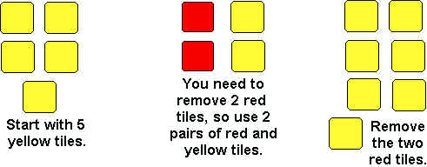
Copyright ©1999-2003 Oswego City School District Regents Exam Prep Center

Questions that participants can ask their students:
- When you add two positive integers, is the sum positive, negative, or impossible to predict?
- Can you predict the sign of the sum when you add two negative integers? Why?
- Can you predict the sign when adding a positive and a negative integer? Explain.
- How is adding integers different from adding whole numbers?

Suggested examples for Addition and Subtraction:

2 + -6 -20 + 15 12 + -5 -5 + -10 5 + -3

9 - 12 13 + -5 -4 – (-4) 1 + 13 -14 + 8

11 - 13 13 – 12 -7 - 2 5 – (-1) -15 + -7

Multiplication <Use Transparency 58>

To multiply integers using your algebra tiles you will need to use the INTEGER PIT. | 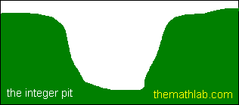
In any multiplication of integers problem, the first number tells you how many groups of tiles to add to the pit (+), or remove from the pit (-).
The second number tells you what will be inside of each group.
For example, let's say you want to find  3 x (-2) = ?  This would mean you are adding 3 groups of -2 tiles to the pit. | 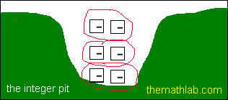
 | The pit now holds the answer to the problem......six negative tiles, or -6. So 3 x (-2)= -6.
Let's try a harder one.  Say you wanted to find  -4 x (-2) = ?  This means you need to remove 4 groups of -2 from the pit.  To do this we will have to fill the pit with a bunch of ZEROS. | 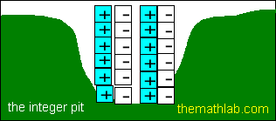  *Remember that a ZERO is created whenever we place a positive tile directly beside a negative tile. They nullify each other.
Basically, the pit looks full but it has NOTHING of value in it...just a bunch of zeros.  Let's circle four groups of -2 tiles for removal. | 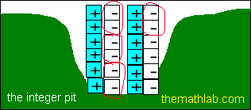
This is what the pit looks like after we remove the groups of negative twos.  There are still a few zeros left, but remember they mean nothing.  We can remove the zeros to better see the actual answer. | 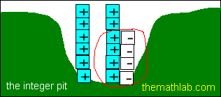
 | 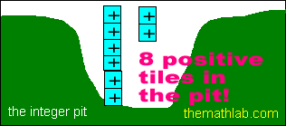
Removing four groups of negative two tiles, leaves us with 8 positive tiles.
So -4 x -2 = 8

NOTE: Using two-color counters does not work for all cases of division and is not part of this session.

Transparency

