   | CRESC Annual Conference  2 - 4 September, 2009  University of Manchester  Call for Papers | 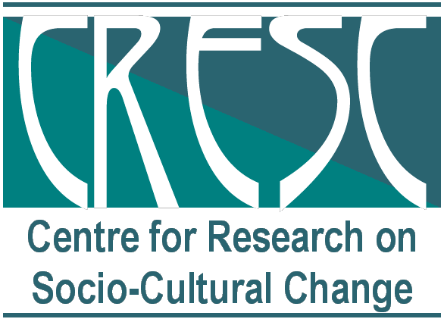

Objects - What Matters?
Technology, Value and Social Change

As contemporary social theorists continue to signal the need to reconfigure our deliberations on the social through attention to practice, to object-mediated relations, to non-human agency and to the affective dimensions of human sociality, this conference takes as its focus the objects and values which find themselves at centre stage. And we ask, in the context of nearly two decades of diverse disciplinary approaches to these issues, what matters about objects? How are they inflecting our understandings of technology, of expertise, and of social change? How has a focus on objects reconfigured our understandings of how values inflect the ways in which people make relations, create social worlds, and construct conceptual categories? How have objects become integral to human enthusiasms and energies, to transformational ambition, or to the transmission of values across time and space? How do objects move between ordinary and extraordinary states, shade in and out of significance, manifest instability and uncertainty? How do moral and material values attach to objects as they move in space and time? What dimensions do they inhabit and/or reveal? To address these questions we welcome papers on the following themes.

Themes

- The transformational work of everyday objects
- Object-centered learning
- Materiality, Stability and the State
- Radical Archives – within and beyond textual assemblages
- Conceptual Objects and Methods as Objects
- Immaterial Objects – haunting, virtuality, traces.
- Financial Objects
- Affective Objects
- Ephemera, Enthusiasm and Excess
- Spiritual and/or Moral Objects
- Controversial and Messy Objects

Keynote speakers to date include: Avery Gordon (UC Santa Barbara), Graham Harman (American University Cairo), Annemarie Mol (University of Twente), Kathleen Stewart (University of Texas, Austin)

Please submit either (a) 300 word abstracts for individual papers, or (b) proposals for panels including 3 papers by the end of February 2009. Proposal Forms are available online at www.cresc.ac.uk and should be sent to:
CRESC Conference Administration
178 Waterloo Place, Oxford Road, University of Manchester, Manchester M13 9PL
Tel: +44(0)161 275 8985 / Fax: +44(0)161 275 8985 / cresc@manchester.ac.uk / http://www.cresc.ac.uk

