ISCAR 2008
Fireside Chat Sessions

3 Special Informal Conversation Opportunities with Leading CHAT Researchers in The Loft Room, Level 2, Price Center (East) UC San Diego

Carl Ratner, Director of the Institute for Cultural Research and Education
Tuesday, September 9, 8-9:30 pm

Lois Holzman, Director East Side Institute for Group & Short Term Psychotherapy, NYC

Wednesday, September 10, 9:30-11:00 am

Alex Kozulin, Director of Research at the International Center for the Enhancement of Learning Potential, Jerusalem
Friday, September 12, 3:30-5:00 pm

***Special 4th Session***
Michael Cole, LCHC UC San Diego
Convenes On Second Life Internet Web Site
Friday, September 12, 7:30-8:30a.m
Carl Ratner

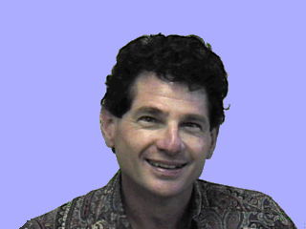

Contact:
Carl Ratner
P.O. Box 1294
Trinidad, CA, 95570, USA
E-mail: cr2@humboldt1.com

Carl Ratner is Director of the Institute for Cultural Research and Education, United States
He has been developing a theoretical and methodological approach to cultural psychology for several decades. He has published Cultural Psychology and Qualitative Methodology: Theoretical & Empirical Considerations (Plenum, 1997) and Cultural Psychology: Theory & Method (Plenum, 2002), Cultural Psychology: A Perspective on Psychological Functioning and Social Reform (Erlbaum, 2006). The volume Macro Cultural Psychology: A Political Philosophy of Mind (Oxford University Press) is forthcoming in 2010.

Ratner currently gives workshops on qualitative methodology especially in relation to cultural psychology. His articles can be read on his web site: http://www.humboldt1.com/~cr2.
Lois Holzman



Lois Holzman, Ph.D.
Director
East Side Institute for Group & Short Term Psychotherapy
920 Broadway, 14th floor

New York NY 10010

Tel: 212-941-8906
Fax: 212-941-0511
lholzman@eastsideinstitute.org

Lois Holzman is the director and a founder of the East Side Institute for Group and Short Term Psychotherapy, a New York City-based international research and training center for new approaches to human development and community. As a leading proponent of a cultural approach to human learning and development, she has made the writings of Lev Vygotsky relevant to the fields of psychotherapy, education and organizational development. She is well known for her pioneering work in exploring the human capacity to perform and its fundamentality in learning how to learn.

Holzman has written or edited nine books and over sixty articles on human development and learning, psychology, education and social therapy; among them: Performing Psychology: A Postmodern Culture of the Mind; Schools for Growth: Radical Alternatives to Current Educational Models; Lev Vygotsky: Revolutionary Scientist (with Fred Newman); and Psychological Investigations: A Clinician’s Guide to Social Therapy (with Rafael Mendez).

Forthcoming, December 2008 Vygotsky at Work and Play

Alex Kozulin

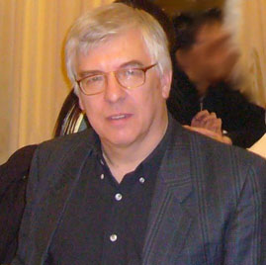

Alex Kozulin is Research Director of the International Center for the Enhancement of Learning Potential in Jerusalem, and teacher at Tel Aviv University and Hebrew University. Born n in Russia he earned his Ph.D. in Psychology at the Psychological Institute in Moscow. From 1980 to 1990 he was conducting research and teaching at Boston University in the US. He was a visiting scholar at Harvard University and a visiting professor at the University of Witwatersrand, South Africa and University of Exeter, UK. Dr. Kozulin is one of the major specialists in Vygotsky’s sociocultural theory and theory of mediated learning. He is the author of Vygotsky's Psychology: A Biography of Ideas (Harvard University Press, 1990), Psychological Tools: A Sociocultural Approach to Education (Harvard University Press, 1998) and co-author with J.Kinard of Rigorous Mathematical Thinking (Cambridge University Press, 2008). He is a co-editor of Experience of Mediated Learning (Pergamon Press, 2000) and Vygotsky’s Educational Theory in Cultural Context (Cambridge University Press, 2003).

Contact information:

kozulin@post.tau.ac.il
alexk@icelp.org.il

