THE HORIZONTAL DIMENSION OF EXPANSIVE LEARNING: WEAVING A TEXTURE OF COGNITIVE TRAILS IN THE TERRAIN OF HEALTH CARE IN HELSINKI

Yrjö Engeström
University of California, San Diego and University of Helsinki

Paper presented at the international symposium 'New Challenges to Research on Learning', March 21-23, University of Helsinki, Finland. Send comments to the author at yrjo.engestrom@helsinki.fi

THE HORIZONTAL DIMENSION OF EXPANSIVE LEARNING: WEAVING A TEXTURE OF COGNITIVE TRAILS IN THE TERRAIN OF HEALTH CARE IN HELSINKI

Yrjö Engeström
University of California, San Diego and University of Helsinki

INTRODUCTION

The purpose of this paper is to bring together two previously quite different and distant theoretical approaches, namely the theory of expansive learning (Engeström, 1987) and the theory of cognitive trails (Cussins, 1992).

There is a good reason for this endeavor. Expansive learning processes are increasingly often studied and facilitated by interventions in multi-organizational terrains of object-oriented activity. Such terrains are occupied by multiple activity systems which commonly do not collaborate very well although there are pressing societal needs for such collaboration. In other words, we may talk of divided terrains.

Health care in a large city such as Helsinki is a good example of a divided terrain. The empirical data of this paper is taken from this domain. Other examples currently studied at the Center for Activity Theory and Developmental Work Research include partnerships between manufacturing companies, investigation of economic crimes in collaboration between multiple agencies, and construction of a broadband electronic network for residents and businesses in a city district by a loose consortium of multiple organizations. In such divided terrains, expansive learning needs to take shape as renegotiation and reorganization of collaborative relations and practices between and within the activity systems involved.

This is radically different from traditional workplace learning which mainly consists of workers becoming competent or improving their competencies within the established practices and along the established measures of their own activity systems. Standard notions of workplace learning cherish a vertical view of competence and expertise. Characteristic to this view is a discourse of 'stages' or 'levels' of knowledge and skill. Such a vertical image assumes a uniform, singular model of what counts as an 'expert' in a given field. However, the world of work is is increasingly organized in ways that require horizontal movement and boundary crossing.

“In their work, experts operate in and move between multiple parallel activity contexts. These multiple contexts demand and afford different, complementary but also conflicting cognitive tools, rules, and patterns of social interaction. Criteria of expert knowledge and skill are different in the various contexts. Experts face the challenge of negotiating and combining ingredients from different contexts to achieve hybrid solutions. “ (Engeström, Engeström & Kärkkäinen, 1995, p. 320)

The theory of expansive learning has primarily been used to study learning involved in major transformations within a single activity system. The basic model of expansive learning is a cycle or a spiral. This essentially forward-aiming model needs to be complemented with movement along the horizontal dimension - with sideways movement between the various activity systems and actors involved.

Concept formation is a useful example of the complementarity of vertical and horizontal dimensions. In his classic work, Vygotsky (1987) basically presented the process as a creative meeting between everyday concepts growing upward and scientific concepts growing downward. However, especially in divided terrains of activity, multiple competing ideas often emerge and collide as candidates for the new concept. In such contexts, concept formation typically occurs as stepwise two-dimensional negotiation and hybridization. The first step may be a debate between an administratively given pre-articulated (‘scientific’) concept and situated articulations of (‘everyday’) experience. This may lead to a proposal for an alternative ‘scientific’ concept, again contested by some participants on experiential grounds, etc. The alternative proposals may often be traced to the cultural resources of different participating activity systems (see Engeström, 2001a).

Such horizontal or sideways movement needs to be conceptualized and modeled on its own terms. The theory of cognitive trails offers a promising vocabulary and model for depicting and analyzing this movement.

EXPANSIVE LEARNING

The basic model of expansive learning may be depicted as an ideal-typical cyclic sequence of epistemic learning actions (Figure 1).
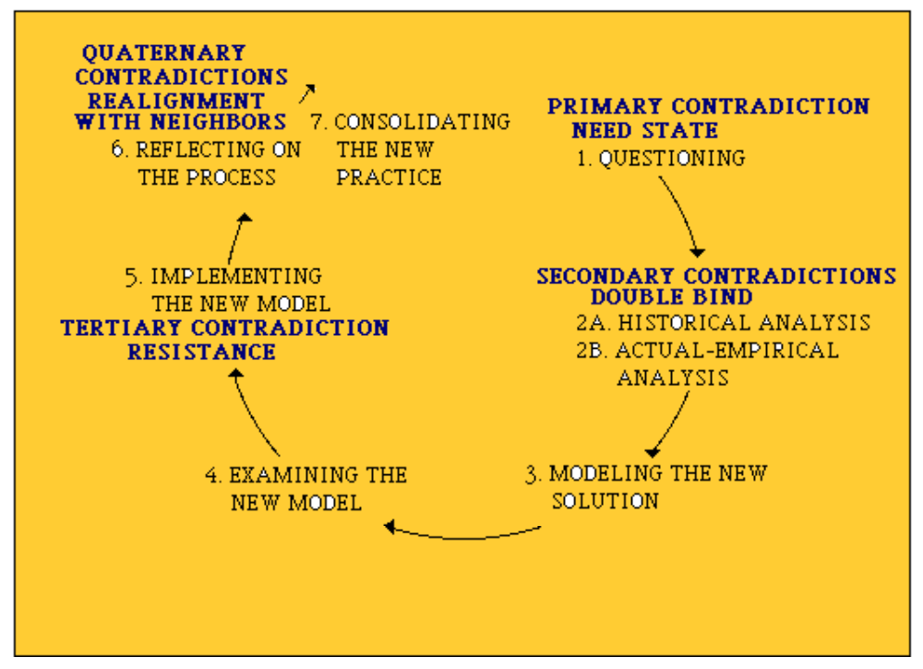
Figure 1: Ideal-typical expansive cycle of epistemic learning actions (Engeström, 2001a, p. 152)

Multi-organizational divided terrains turn our attention to research settings where the unit of analysis consists of mininally two interacting activity systems that have a partially shared object (Figure 2).

Figure 2: Two interacting activity systems with a partially shared object (Engeström, 2001a, p. 136)

There are more or less sharply marked and penetrable boundaries between activity systems occupying a divided terrain. In this paper, I will not go into the characteristics of the various types or layers of these boundaries (this is the thesis topic of Hannele Kerosuo within our research project). Here it is sufficient to state that this new focus demands that we reformulate expansive learning actions as boundary-crossing actions.
The ideal-typical sequence of such actions may be something like this:

*questioning, challenging and rejecting existing practices across boundaries,
*analyzing existing practices across boundaries,
*collaborative, mutually supportive building of new models, concepts, artifacts or patterns of conduct across boundaries,
*examining and debating suggested models, concepts, artifacts or patterns of conduct across boundaries,
*emulating and appropriating new ideas, concepts, artifacts or patterns of conduct across boundaries,
*negotiating, bartering and trading of material or immaterial resources related to new ideas, concepts, artifacts or patterns of conduct across boundaries,
*reflecting on and evaluating aspects of the process across boundaries,
*consolidating the outcomes across boundaries.

Boundary-crossing actions are always two-way inter-actions. If only one party attempts to cross a boundary but receives no response, the action is incomplete and cannot be categorized as boundary crossing. To be expansive, such actions need to be characterized by mutual engagement and commitment to change in practices. Moreover, whether or not a boundary-crossing action is expansive can ultimately only be determined in the broader context of transformation in the activity systems involved.

“Miniature cycles of innovative learning should be regarded as potentially expansive. A large-scale expansive cycle of organizational transformation always consists of small cycles of innovative learning. However, the appearance of small-scale cycles of innovative learning does not in itself guarantee that there is an expansive cycle going on. Small cycles may remain isolated events, and the overall cycle of organizational development may become stagnant, regressive, or even fall apart. The occurrence of a full-fledged expansive cycle is not common, and it typically requires concentrated effort and deliberate interventions. With these reservations in mind, the expansive learning cycle and its embedded actions may be used as a framework for analyzing small-scale innovative learning processes.” (Engeström, 1999, p. 385)

In other words, in an analysis of shorter sequences of learning, the we can only identify expansive actions in a preliminary and tentative way. Thus, at this level of analysis it is appropriate to talk about learning actions with expansive potential.

COGNITIVE TRAILS

Adrian Cussins' theory of cognitive trails is a philosophical critique of and alternative to various forms of conceptualism. It is essentially a theory of embodied cognition where the basic metaphor is that of a person moving in a territory. The key concepts are perspective-dependence (PD) and stabilization.

Imagine a person standing somewhere in the middle of a city. The person's ability to find his or her way to any desired location regardless of the person's initial position is called perspective-independence. In such case, the PD ratio is high - close to 1. The PD ratio is close to zero when the person is completely unable to find his or her way to any desired location in the territory.

People learn to move around in a territory by moving around in the territory. In so doing, they make cognitive trails.

"Trails are both person-made and world-made, and what makes persons and worlds. Trails are in the environment, certainly, but they are also cognitive objects. A trail isn't just an indentation in a physical surface, but a marking of the environment; a signposting for coordinating sensation and movement, an experiential line of force. Hence the marking is both experiential and environmental. " (Cussins, 1992, p. 673-674)

"Each trail occurs over time, and is a manipulation or a trial or an avoidance or capture or simply a movement. It is entirely context-dependent… Yet a trail is not transitory (although a tracking of a trail is): the environmental marking persists and thereby the ability to navigate through the feature-domain is enhanced." (Cussins, 1992, p. 674)

As multiple trails are marked, some trails intersect. Intersections are landmarks. A territory is structured by means of a network of landmarks. Such structuring means increasing the PD ratio.

Along with the PD ratio, there is another dimension that characterizes the development of cognitive trails, namely stabilization. Stabilization may also be characterized as blackboxing.

"Stabilization is a process which takes some phenomenon that is in flux, and draws a line (or builds a box) around the phenomenon, so that the phenomenon can enter cognition (and the world) in a single act of reference…" (Cussins, 1992, p. 677)

"There comes a time when it is best to stabilize a network of trails so that the space is treated cognitively (functions) as a given unit (an object!), and then build higher-order feature-spaces …" (Cussins, 1992, p. 679)

"One familiar and important way in which stabilization is achieved is by drawing a linguistic blackbox around a feature-space: the imposition of linguistic structure on experiential structure. … A region of feature-space starts to function as an object as it is dominated by a network of trails and stabilized by a name." (Cussins, 1992, p. 679-680)

Stabilization of
Cognitive trails

PD ratio of cognitive trails

Figure 3: Generality as high PD ratio and high stabilization (Cussins, 1992, p. 683)

In Figure 3, the point of maximum generality is depicted with the help of an oval. This is where objects, concepts and explicit propositions emerge.

Cussins depicts cognition as "appropriate spiraling" in the two-dimensional terrain depicted above. He calls this movement “virtuous representational activity.”

“The course of a cognitive phenomenon (a dynamic, representational activity) may be plotted on a graph whose axes are the PD ratio of the cognitive trails and the degree of stabilization of the cognitive trails. Let us suppose that an activity starts out with low PD ratio and low stabilization. As the field starts to become structured – the creatures start to find their way around a landscape (as the theorist would say) – PD ratio will increase. A network of cognitive trails is temporarily established, and this provides for the possibility of stabilization. Both stabilization and PD ratio continue to increase, until the work of concentrates almost entirely on the stabilization of trails that are in place. However, once a network of trails is tightly stabilized it becomes less flexible, and as the nature of the field of activity changes over time, PD ratio will start to decrease as stabilization increases. Further improvement in way-finding will then require that a stabilized region of cognitive trails be established for a period of time in order to allow PD ratio to increase again. In other words, virtuous representational activity is the effective trade-off of the relative merits and demerits of PD ratio and stabilization. Virtuous activity may itself be represented as a figure, a shape, in the two-dimensional space of the PD ratio/stabilization graph. It is not hard to see that the virtuous form of representational activity has the shape of a spiral (Figure 4; Cussins, 1993, p. 249-250)

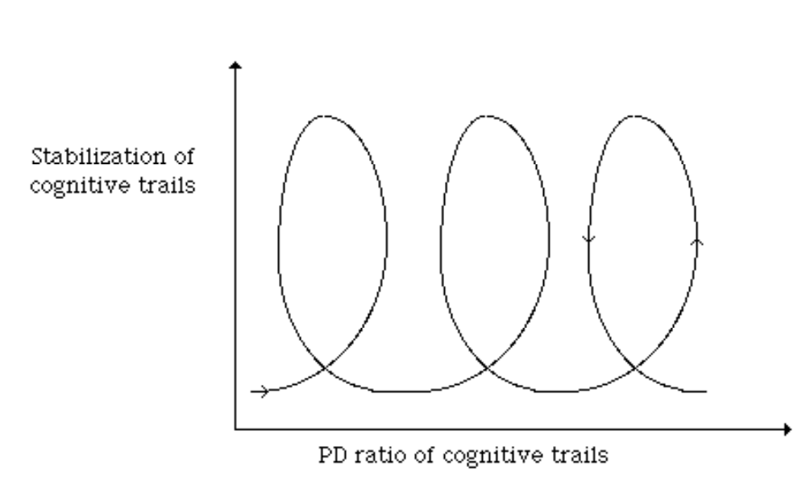
Figure 4: The spiral of virtuous representational activity (Cussins, 1993, p. 250)

In renegotiations of divided multi-organizational terrains, cognitive trails are typically made in multi-party discussions. The trails become manifest when there are attempts at stabilization and generalization (Cussins, 1992). In other words, collectively and discursively produced cognitive trails are identifiable by their attempts at articulation of explicit ideas or concepts, typically in the form of proposals or definitions.

In a divided terrain occupied by multiple activity systems, cognitive trails relevant for the horizontal dimension of expansive learning also include boundary-crossing actions. So the “appropriate spiraling” or “virtuous representational activity” described by Cussins is here understood as taking appropriate expansive boundary-crossing actions, or working through the cycle of expansive learning. The theory of cognitive trails and the theory of expansive learning are thus brought together.

THE CONTEXT AND THE INTERVENTION

I will now present an analysis of the creation of cognitive trails in discussions among practitioners and patients of the health care organizations in Helsinki. The terrain of object-oriented activity in this case is the health care of patients with multiple illnesses, particularly in the domain of internal medicine.

The terrain is divided between multiple institutionalized activity systems. The most important ones are the Helsinki University Central Hospital and its various clinics on the one hand and the primary care health centers owned and operated by the City of Helsinki on the other hand. The health centers purchase special care services from the University Central Hospital for the populations in their respective areas. In terms of economics, health centers are paying customers. In terms of medical specialization and professional status, health center general practitioners are subordinate to specialist physicians of the University Central Hospital. To mediate between these two organizations and to reduce excessive referrals to the University Central Hospital, the board of health of the City of Helsinki recently established separate consultation clinics within the health centers. A consultation clinic is run by specialist physicians whose domains of responsibility cover broader ranges of specialization than those typical of the physicians at the University Central Hospital.

Besides these three caregiver activity systems, the managements of the University Central Hospital and of the city's board of health may be regarded as activity systems of their own.

Finally, each patient represents an activity system. Although not financially and institutionally a big player in this divided terrain, the patient has power that stems from the fact that actual decisions to seek care and to follow the prescribed courses of treatment (e.g., medication) are ultimately done by the patient (and/or his/her family).

A critical structural issue in the Helsinki area is the excessive use of high-end hospital services, historically caused by a concentration of hospitals in this area. Due to rising costs, there is now much political pressure to change this division of labor in favor of increased use of primary care services.

The problem is most acute among patients with long-term illnesses, especially those with multiple or unclear diagnoses. Such patients often drift between caregiver organizations without anyone having overview and overall responsibility of their care trajectories. This puts a heavy burden on the patients, their families, and on the society.

Based on our previous historical and empirical analyses of the field of health care in Helsinki (Engeström, Engeström & Vähäaho, 1999; Engeström, 2001b), our hypothesis is that the learning challenge in this setting is to acquire a new, negotiated way of working in which patients and practitioners from different caregiver organizations will collaboratively plan and monitor the patient’s trajectory of care, taking joint responsibility for its overall progress. For short, we call this negotiated knotworking. In terms of mastering their contradictions, this may be understood as a major step forward or upward for the activity systems involved. On the other hand, achievement of such a step itself requires learning in dialogue across organizational boundaries, that is, a determined opening-up of the horizontal dimension.

The board of health of City of Helsinki and the Helsinki-Uusimaa hospital district asked our research group to conduct an intervention study in the years 2000 and 2001, aimed at helping practitioners in the two organizations learn to work collaboratively and to manage the care of patients in a negotiated manner. The project was asked to focus on internal medicine patients having multiple diagnoses and using the services of both organizations in parallel.

The working method of our project is to build detailed cases out of selected patients' experiences with the health care system. We interview these patients on video, we follow them to consultations and videotape the encounters, we interview their caregiver practitioners on video, and we collect all the medical records and other relevant documents related to the selected patients. Data collection on one patient typically lasts up to two months. We edit the data into a set of video excerpts that make visible the problems and gaps in care collaboration. We construct a care calendar listing the main events in the patient's illness history, and a care map which graphically depicts the different caregiver organizations used by the patient as well as the nature and frequency of contacts between the parties involved in the patient's care.

The practitioners involved in the care of the patient, plus the patient him- or herself, are then invited to attend an Implementation Laboratory session (Figure 5). The name 'Implementation Laboratory' refers to the task of facilitating the implementation of a negotiated way of working across organizational and professional boundaries. This is a variation of the generic Change Laboratory method developed at the Center for Activity Theory and Developmental Work Research (Engeström & al., 1996).

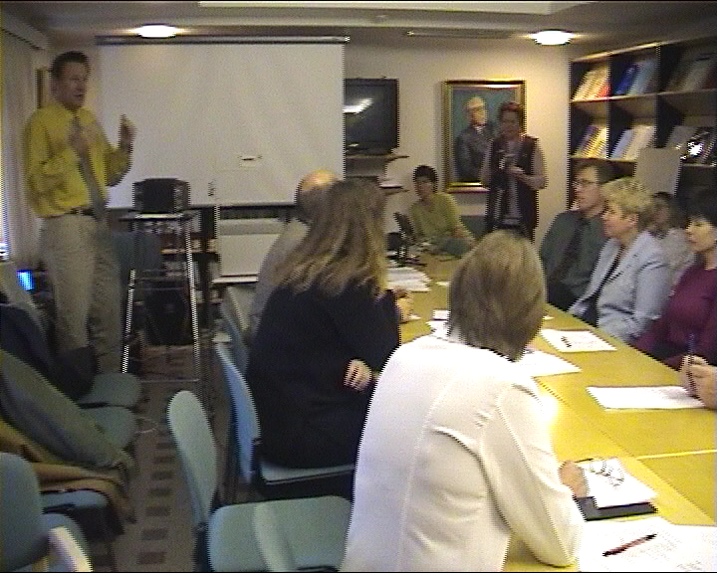

Figure 5: The Implementation Laboratory in session at a health center in Helsinki

In a laboratory session, we first introduce the patient's care calendar and care map. We then view the video excerpts and ask the participants to discuss them in order to identify problems, their systemic causes, and possible remedies or solutions. Problems, causes, and suggested solutions are written up on whiteboards by a scribe. A laboratory session lasts two hours. The sessions are videotaped for analysis. The participants subsequently receive a memo based on the notes recorded on the whiteboards during the session.

In the following, I will analyze one Implementation Laboratory session held at a health center. This particular laboratory session was the first one in a series of ten sessions conducted during 2000, the first year of our project. The session was attended by the patient, a heart specialist physician from the University Central Hospital, four health center general practitioners (one of whom was the patient's personal physician), a health center nurse, an internal medicine specialist physician from the consultation clinic of the health center, an administrator physician from the city's board of health, and four researchers from our team.

The patient, named Tom, was a 63-year old retired man with a severe heart condition, diabetes and kidney disease. He was treated in parallel in the Helsinki University Central Hospital (mainly in the cardiology clinic and the lung clinic), the health center of the area of his residence, and the consultation clinic. Tom introduced himself in the laboratory session as follows.

004 Patient: Yes, I am Tom K., retired at this point, and the last thirty
years of my working life I spent in different rationalization
tasks, mainly in small and medium-sized industrial plants….
And in 1990 I had to have the first bypass surgery, when the functioning of the heart began to fail. The pace in work was a bit too hectic, I couldn’t keep up even with the help of [name of heart medicine]. So roughly ten years went by, and the heart began to fail again a couple of years ago, and they performed a new bypass surgery two years ago in December. And as end result, the situation didn’t improve much. I was left with a fairly severe heart deficiency which limits my daily life quite a bit. I mean, my capacity is very restricted. I am 63 years old.

Tom’s care map, summarizing his caregiver contacts during the year preceding the laboratory session, is presented in Figure 6.

[INSERT FIGURE 6 HERE]

Figure 6: Tom's care map

The two-hour laboratory session contained 302 turns of talk. The discussion was divided into three broad themes: (1) interpretation of the patient's problem/s, (2) the flow of information, and (3) division of care responsibility. Each discussion theme was opened by viewing a set of pertinent video excerpts recorded and edited by the researchers. The video clips consisted of interviews with the patient and the different caregivers as well as episodes from consultations. Figure 7 summarizes the different parties' views on the patient's chief problem as they were expressed in the first set of video clips.

[INSERT FIGURE 7 HERE]

Figure 7: Different conceptions of Tom's chief problem

Figure 7 makes it clear that the different caregivers had quite different and partial images and definitions of Tom’s condition. The patient characterized his own main problem as troubles in breathing during the night. The only caregiver who seemed aware of this issue was the hospital lung specialist. Others, including Tom’s personal physician, did not take up this problem.

BLAZING COGNITIVE TRAILS

An analysis of the transcript reveals three manifest cognitive trails made by the participants during the session. Based on the articulated stabilization proposals made by participants, these three trails may be initially characterized as follows:

- (1.1) Send report from every hospital visit to the health center -> (1.2) Collection of hospital reports as a 'handbook' for the general practitioner

- (2.1) Concentrate care responsibility in the University Central Hospital's cardiology clinic -> (2.2) Concentrate coordination responsibility in the health center's consultation clinic -> (2.3) Negotiate an agreement on the division of responsibility -> (2.4) Negotiate a shared one-year plan of care -> (2.5) Define caregivers to be contacted in different urgent situations

- (3.1) General practitioner should conduct a thorough 'entrance examination' with a new patient -> (3.2) Increase the maximum duration of consultation at the University Hospital from 30 minutes to 45 or 60 minutes for patients with multiple illnesses

Table 1 shows that the three trails emerged partly successively, partly in parallel.

Table 1. Three cognitive trails made in the laboratory discussion

TRAIL 1 TRAIL 2 TRAIL 3
___________________________________________________
Turn 48
Turns 53-60
Turns 72-78
Turns 88-89
Turn 95
Turns 108-117
Turns 123-125
Turn 130
Turns 131-133
Turn 137
Turns 143-154
Turns 155-165
Turn 210
Turns 216-243
Turns 243, 246
Turn 248
Turns 249-250
Turns 263-271
___________________________________________________

The first cognitive trail began after the first set of video excerpts was shown to the participants. The experts depicted the patients and several caregivers giving different accounts of the patient's chief problem. The contents of the excerpts are summarized in Figure X. The researcher moderating the session asked the patient whether he saw any problem in the excerpts.

048 Patient Yes, there is the problem that it is pretty difficult for them to get an overall picture of the situation, or even an accurate
picture. Because as far as I understand the main materials are
solely under the control of the University Central Hospital… the patient files.

When asked, the patient's personal health center physician (general practitioner or GP 1) made clear (turn 53) that she had been kept in the dark concerning the reasons for the patient's critical medication - which she was, however, required to monitor. When asked whether she had received paper reports from the hospital, she indicated (turn 56) that she had papers from ten years back but nothing more recent. She pointed out that it would have been useful to know what was the diagnosis behind the medication. The physician continued this line of critical questioning in several occasions during the session.

The first stabilization attempt (1.1) was made by the specialist physician of the health center's consultation clinic. She proposed that a report should be sent from the hospital to the health center after every visit of this patient. The heart specialist's affirmative response indicated boundary crossing.

059 Consultation clinic physician … But here it sounds that the
patient visits the cardiology clinic once a month, so it would be good to send a report from each visit to the patient's own health center. Since the cardiology clinic certainly knows that the health center physician monitors the Marevan treatment,. So if the report were sent, the party monitoring the Marevan treatment would know the situation concerning the heart's prognosis and such.
060 Heart specialist Yes, that would probably be quite appropriate.

However, horizontal expansion seldom works so smoothly. Soon enough (turn 75) the heart specialist asked, whether health center physicians really would have time to read interim reports from the hospital. Somewhat later, another health center general practitioner (GP 2) responded.

114 GP 2 Yes, we will. We'll have time. It's another matter
what one's brain will register and how the information will be utilized. But we'll have time. I think the essential question is why is it so that the reports are not sent. …

The heart specialist responded (turn 117) by referring to two practical obstacles, namely regulations protecting patients' anonymity and the inertia involved in typing and mailing the reports.

After this exchange, the consultation clinic physician made another attempt at stabilization (1.2) by proposing the concept of 'handbook'.

123 Consultation clinic physician But I'd still like to comment on
whether health center physicians ever read hospital reports when they are sent in large quantities. I see it so that hospital reports and interim feedback are like a handbook for the health center physician. He or she does not necessarily read them more than glance through them quickly, but when there is a problem, they are available as a kind of handbook to which one returns and finds the information, and they are useful as such. He or she doesn't know them by heart. But the information is available when the documents are there. In that way it's important to possess them, as a kind of a handbook.

Notice that the stabilization attempt included three times the word 'handbook'. The consultation clinic physician got support from a health center physician (GP 3, turn 125), but not anymore from the heart specialist. However, yet another health center physician (GP 3) continued by suggesting that the heart specialist should take the responsibility for summarizing interim reports from all clinics of the University Central Hospital where the patient visits (turn 130). The heart specialist responded by changing the topic and initiating the second cognitive trail.

131 Heart specialist …I'd like to toss up an unorthodox, and not
fully thought-out idea, what if…
132 Researcher Sounds like it belongs to the middle board…
[referring to a whiteboard reserved for new ideas and solutions]
133 Heart specialist Yes. If the patient is making so frequent
follow-up visits to the hospital, then Marevan, well it will be interesting to hear comments, whether in this case it would be reasonable to monitor even the Marevan treatment in …

Here the heart specialist very tentatively proposed that care responsibility might in this case be concentrated in the hospital cardiology clinic (turn 53). The proposal (2.1) was 'unorthodox' because it ran counter to the general thrust of recent reforms moving more responsibility into the hands of primary care. In spite of its tentative tone, the heart specialist's proposal can be seen as an attempt at stabilization. In a way, it was a logical though surprising response to the pressure to send feedback reports to the health center: if all care takes place in the hospital, no feedback reports would be needed. Thus, this proposal opened the second, rather complex cognitive trail around the issue of care responsibility.

However, the second trail was not immediately pursued by others. Instead, the patient's personal physician changed the topic and initiated the third cognitive trail around the need for comprehensive consultations with complex patients. After once again expressing her frustration with the missing reports from the hospital, she mentioned that a short "half-minute" telephone consultation typically leaves a lot of information undisclosed.

137 GP 1 … What interests me is that the health center physician
does not have the heart to ask the patient to come to the consultation, because she [the GP] thinks that she can manage with the help of a phone conversation….

This short reflection soon led to a stabilization attempt (3.1) initiated by the administrator physician from the city's board of health.

143 Administrator physician I'm starting here to think about a
question which is partly based on the fact that we do have regional population responsibility. In other words, you live in a certain area, which determines who is your physician. Our patients do not actively enlist with anybody . I mean there is no such entrance examination for a patient at the health center. In which the health center physician could kind of create a picture of what this patient is, what is his or her background, and how one is to proceed in broad terms. And I mean, this is just a thought, I haven't considered the resources and possibilities, but would this be a place for development? So if one has multiple illnesses, one would have, and this is actually the case of course, but as soon as one knows that some part is happening somewhere, should the person sort of enlist more actively? Let this be just a background idea…
144 Researcher Kind of enlist, or..?
145 Administrator physician Yes, to register as a patient. "Mary [name of the patient's personal physician] , I am your patient, and this
is my problem." So that Mary won't first be hit by a request for Marevan treatment, "I need a dose," because the care [in the hospital] is still going on. It is the first contact, it is always interesting in itself.
146 Researcher Mmm, yes. Yes.
147 GP 3 Well, that is quite true…

The stabilization effort again took the form of repetition: the word 'enlist' was repeated three times. The administrator physician accompanied her proposal with hedges and hesitations: "I mean, this is just a thought … but"; "and this is actually the case of course, but"; "let this be just a background idea". On the other hand, she also used twice the often quite powerful tool of reported speech: "Mary, I am your patient, and this is my problem"; "I need a dose".

Although the administrator physician's stabilization attempt was met favorably by the researcher moderating the session and by one of the GPs, it did not at this point lead to further elaboration. Instead, the heart specialist turned the trail to a related concern of his. He made an alternative attempt at stabilization (3.2) by stating that the 30-minute normative duration of the consultation at the cardiology clinic is not enough for patients with multiple illnesses.

148 Heart specialist … Whereas if the consultation length could be
increased to, let's say, 45 minutes or an hour, then we could kind of take care of the kidney problem, diabetes, cardiological problem within one visit. …

After a couple of questions concerning the normative length of consultations at the University Central Hospital, the discussion refocused on the question whether indeed the care for the patient's multiple illnesses should be concentrated in the cardiology clinic. In other words, the discussion returned to the second cognitive trail.

GP 2 initially (turn 163) seemed to lean toward accepting the heart specialist's 'unorthodox' proposal (recall turns 131-133), while the administrator physician expressed doubts about it (turn 165).

163 GP2 … I mean, it will not work if we just kind of categorically,
always and in every case, transfer the overall responsibility
to the health center. And that’s why I return to your more unorthodox idea, that maybe we shouldn’t always be so dogmatic that we always dig up the responsible physician in the primary care, it can just as well be in specialized hospital care. We can very well take that as a starting point, in my opinion. …
…
- Administrator physician: Well, my question is actually the opposite, or it is
addressed to the Cardiology Clinic, in that do you think that the patient’s heart disease is so serious that a monthly visit to the Cardiology Clinic is absolutely necessary? And that we could not for example continue so that we, after we have an overall plan for the care, and we know, that the care would be given at the health center, or in this case at our consultation clinic? One would of course have to ask the patient, too, as to where it would be, and what would be the level of the care. Do you think that it cannot be a health center physician…? That information cannot be shared so much, and it would be agreed upon, that control visits to the hospital Cardiology Clinic are at certain intervals, and of course more often if needed? I mean this would be worth looking at from both sides, kind of.

A clear alternative proposal (2.2) was eventually articulated by the consultation clinic physician who (in turn 216) suggested that the consultation clinic could take responsibility for following up on the patient's heart condition and coordinating that with the care for diabetes and other illnesses. She pointed out that in the present situation there were three different caregivers treating the patient separately, each one not knowing what the others were doing; this constituted a risk for the patient's safety.

At this point, the researcher moderating the session proposed that an agreement be negotiated between the caregivers and the patient. In his attempt at stabilization (2.3; turn 217), the researcher used six times the word 'agree'. GP 3 supported the proposal, using once the word 'agree' (turn 218).

The administrator physician took the stabilization effort one step further by proposing (2.4; turn 220) that the caregivers and the patient should negotiate a one-year care plan that would contain a prognosis and goals for the course of care to be given by the different parties. An important boundary crossing occurred when the heart specialist reacted to the administrator physician's proposal.

224 Heart specialist Who in your opinion should from the point of view of
the care of the heart deficiency take the initiative with regard to producing the care plan? Who is responsible, who makes it or sees to it that it is made?
225 Administrator physician As I see it, it is still the expertise of the
cardiology clinic to make the plan.
226 Heart specialist Yes, it should be, but there must be a specified person
in the cardiology clinic…
227 Administrator physician Yes.
228 Heart specialist … a man or a woman who does it. The clinic as such
doesn't do anything.
229 Administrator physician No, it doesn't. I'm getting there, I am of course
looking at the only one who is present here, with burning eyes…
[laughter]
230 Researcher You've been put in charge of quite a lot, you know.
231 Administrator physician And then it's Mary, too, in that this is kind of
pressure, if Mary is indeed the personal physician…
……
235 Administrator physician Yes, it is so that the personal physician is here
under the pressure that the plan will be made. …

This discussion was the most the intense and ambitious stabilization attempt in the session. However, it did not lead to an explicit agreement or decision.

Soon after this, there was a sequence in which the discussion moved rapidly and practically without breaks from the second cognitive trail (turns 242-243) to the first trail (turns 243 and 246) to the third trail (turn 248) and back to the second trail (turns 249-250). Cussins (1992, p. 675) points out that intersections of two or more cognitive trails become landmarks of the domain. On the surface, this sequence resembles an intersection, or at least it brings the trails very close to one another. A closer examination reveals, however, that this sequence contains a string of relatively isolated ‘tail ends’ of the three trails rather than any concerted or integrated major stabilization attempt:

-First trail: The patient’s personal physician returned to the first trail by once more complaining about not having gotten information on the patient's hospital care (turns 243 and 246).

-Second trail: The heart specialist added one further, relatively minor attempt at stabilization by proposing (2.5; turn 249) that the parties should have a shared list of specified caregivers to be contacted in various possible emergencies. The researcher stated that such a list should be created as part of the one-year care plan.

-Third trail: In turn 248, the consultation clinic physician quite forcefully reaffirmed the administrator physician's much earlier proposal (see turn 143) of conducting a thorough ‘entrance examination’ with a new patient.

248 Consultation clinic physician I do propose that in this situation, when
a new patient comes to the personal physician, she [the physician] should just set out with a high profile, like Annie [name of the administrator physician] said, and invite the patient to the consultation and order the papers from all parties, and say that "you are now my patient, and we will take care of these, and we will also collect these things here." That's how one must start out.

Notice that this reaffirmed stabilization attempt was again accompanied by reported speech, but there were no hesitations and hedges this time.

The above examination of the ‘tail ends’ makes it clear that temporal proximity is not enough for the formation of substantive intersections of cognitive trails. More refined analyses are needed to disclose early indications of substantive merger or hybridization between trails.

BOUNDARY-CROSSING ACTIONS AND STABILIZATION ATTEMPTS

The three cognitive trails may now be summarized again, now depicting the boundaries crossed as well as stabilization attempts made at various points (Figure 8).

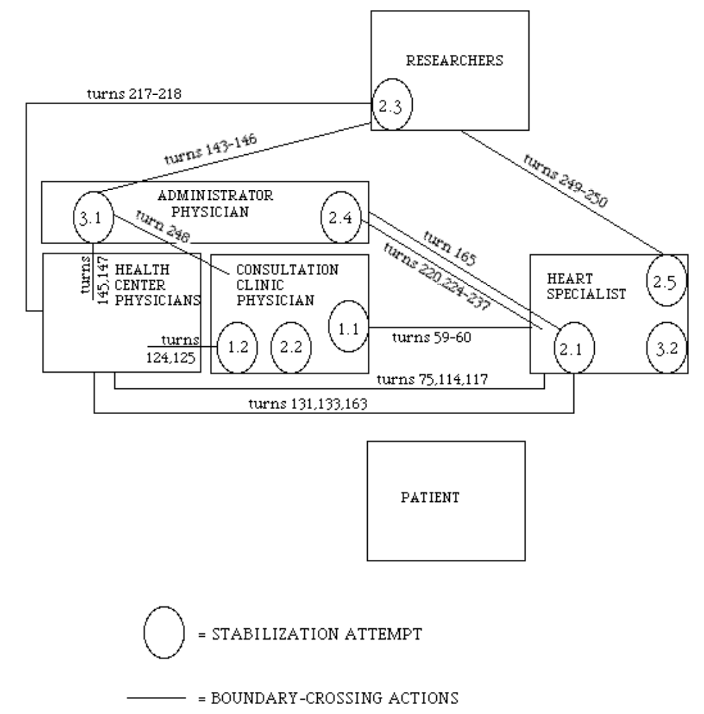

Figure 8: Stabilization attempts and boundary-crossing actions in the three cognitive trails

Figure 8 reveals a few interesting features. First, there were eleven sets of boundary-crossing actions in the three trails - three in the first trail, five in the second trail, and three in the third trail. All but one of the sets of boundary-crossing actions were connected to stabilization attempts. In other words, boundary-crossing actions emerged almost exclusively as means to initiate or respond to stabilization attempts.

Secondly, boundary-crossing actions touched all the other activity systems except the patient. The heart specialist was involved in six sets of boundary-crossing actions, health center physicians were involved in five, the administrator physician in five, the researchers in three, and the consultation clinic physician also in three. Perhaps it is not surprising that the patient was not involved in boundary-crossing actions - but it is certainly a cause for serious concern.

Thirdly, there were nine stabilization attempts in the trails. Interestingly enough, the heart specialist and the consultation clinic physician both made three attempts, the administrator physician made two attempts, and the researchers made one. The health center physicians and the patient made no attempts at stabilization.
Perhaps it is symptomatic that in the medical hierarchy, these two are the least powerful of the activity systems involved. Two of the stabilization attempts (2.2 and 3.2) were made without corresponding boundary-crossing actions. One stabilization attempt (3.1) was connected to three sets of boundary-crossing actions, another attempt (2.1) was connected to two sets of boundary-crossing actions.

THE EXPANSIVE POTENTIAL OF THE BOUNDARY-CROSSING ACTIONS

To what extent did the ten sets of boundary-crossing actions show expansive potential? To answer this question, we need to look more closely into the nature of these actions. As a framework, I will use the tentative list of ideal-typical expansive boundary-crossing actions presented earlier, in the section on expansive learning.

The first set of boundary-crossing actions (turns 59-60) consisted of a proposal made by the consultation clinic physician and an acceptance expressed by the heart specialist. While this interaction could possibly be categorized as 'collaborative, mutually supportive building of new models, concepts, artifacts or patterns of conduct across boundaries', the rather minimal response of the heart specialist makes such a characterization questionable. Mutual engagement and elaboration are missing.

The second set of boundary-crossing actions (turns 75, 114 and 117) consists in effect of three counter-moves. First the heart specialist questioned whether the solution suggested in the previous set would actually be realistic, a health center physician responded affirmatively, and finally the heart specialist presented reasons for the difficulty of implementing the solution. The set is defensive rather than expansive.

The third set of boundary-crossing actions (turns 124-125) was a proposal presented by the consultation clinic physician and accepted by a health center physician. Again, one might categorize this interaction as 'collaborative, mutually supportive building of new models, concepts, artifacts or patterns of conduct across boundaries '. However, the interlocutors were not elaborating on actual changes in their practices. It seems that the consultation clinic physician and the health center physician were in fact aiming their unanimity toward the heart specialist, trying to convince him that interim reports from the hospital can and will indeed be used meaningfully at the health center. Since the heart specialist did not engage in the exchange, it is again difficult to see much expansive potential in it.

The fourth set of boundary-crossing actions (turns 131, 133, 163) contains the heart specialist's 'unorthodox' proposal and the support expressed by one of the health center physicians. This proposal would indeed require changes in both parties' practices. The interlocutors also elaborate on the proposal. This exchange could be seen as an early step toward 'collaborative, mutually supportive building of new models, concepts, artifacts or patterns of conduct across boundaries'.

The fifth set (turn 165) is the critical response to the same proposal by the administrative physician. This may be seen as a fleeting example of 'examining and debating suggested models, concepts, artifacts or patterns of conduct across boundaries'.
While an interesting initiative, the sixth set of boundary-crossing actions (turns 143-146) was only directed at the researchers. The immediately following seventh set (turns 145, 147) may be interpreted as the administrative physician's attempt at 'collaborative, mutually supportive building of new models, concepts, artifacts or patterns of conduct across boundaries'. However, the response from the health center physician was quite minimal and contained no personal commitment to change of practice.

The eighth set of boundary-crossing actions (turns 217-218) was an initiative taken by the researchers and aimed at introducing the idea of agreement between the caregivers and the patient. This and the immediately following ninth set (turns 220, 224-237), which introduced the idea of a shared one-year care plan, were clearly the most ambitious attempts at expansion in the session. Both sets may be seen to represent 'collaborative, mutually supportive building of new models, concepts, artifacts or patterns of conduct across boundaries'. What is problematic is that the patient's personal physician did not engage in the latter set of actions although the administrator physician's words were directly addressed at her (turns 231, 235). In any case, the latter set is intense, containing a rapid exchange of turns between the hospital heart specialist and the health center administrative physician. Interestingly, it is also the only set of boundary-crossing actions in this meeting that contains collective laughter.

The tenth set (turns 249-250) is a brief exchange between the heart specialist and the researcher. The heart specialist's initiative did not elicit engagement and commitment to action among the other parties.

As we can see, four sets out of a total of ten (4, 5, 8 and 9) contained potentially expansive features of mutual engagement and commitment to change in practices. While this is promising as such, the problematic finding is that none of the sets contained an interaction in which all the four parties ultimately responsible for the practical creation and implementation of an agreement or a plan - namely the patient's personal physician, the heart specialist, the consultation clinic physician, and the patient himself - jointly engaged in the discourse. In fact, even the three professionals did not enter in joint exchange in any of the sets.

The ninth set of boundary-crossing actions (turns 220, 224-237) was the most advanced attempt at concept formation in this meeting. The notion of a shared one-year care plan gained momentum for a brief period. Although it was not developed into a stabilized concept in the session, it may well have gained enough stability to reappear in later sessions.

The potentially expansive boundary-crossing actions identified in this laboratory session all represent attempts at constructing a new working model for the activity systems involved. Actions of questioning the existing practice also did appear, especially within the first cognitive trail, performed by both the patient (turn 48) and his personal physician (turns 53, 56, and also later). The reason these actions are not categorized as boundary-crossing actions is that they did not meet a response from the other side of a boundary. Thus, the personal physician’s complaints about not getting feedback from the hospital were met with sympathetic questions and comments by her fellow health center GPs, not with a reaction from the hospital heart specialist.

CONCLUSIONS

The theory of expansive learning needs conceptual tools to incorporate the horizontal dimension of learning into its basic analytical approach. Cognitive trails open up a possibility to analyze the horizontal dimension of expansion in terms of mundane actions and small traces, something badly needed when one wants to make sense of the often unremarkable, piecemeal textures underneath articulated breakthroughs. PD ratio and stabilization are analytical resources that make the theory of cognitive trails empirically useful far beyond the rather metaphorical notion of ‘rhizomes’ (Deleuze & Guattari, 1987). Though elusive, cognitive trails are real and earthly, much like the ‘songlines’ of the Australian Aboriginals (Chatwin, 1987).

Yet the theory of cognitive trails is but one possible extension into the horizontal dimension. The Bakhtinian framework of social languages, voices, and speech genres (R. Engeström, 1995) seems another necessary extension, especially given the relatively non-historical orientation of the theory of cognitive trails.

In my attempt at constructing a workable method for empirical analysis of cognitive trails, I have strongly focused on stabilization attempts. In other words, I have sought to identify elements toward what Tomasello (1999) calls ‘the ratchet effect’ in human learning. This entails the risk that the evolution of the PD ratio is taken less seriously and the analysis becomes biased toward favoring the formation of closed networks at the cost of open-ended trails – a tendency strongly criticized by Cussins (2001). To correct this potential bias, future analyses need to focus more on the overall shapes, interactions and crossings between the multiple cognitive trails.

One objection to the study presented above might be that we are only focusing on words in an artificial laboratory situation. The practitioners' and the patient's practical actions in real field conditions are neglected, which inevitably leads to a false picture of the situation.

This critique forgets that our laboratory sessions are preceded by a lengthy period of fieldwork during which we follow the patient to consultations and record practical actions of medical care. More importantly, medical decision making does to a very large extent happen by means of words. The laboratory sessions are not so artificial as one might think, and they are certainly not traditional training situations. They are held in the workplace during working hours. The participants are encouraged to make and do make actual care decisions in the sessions. Still it is true that data on the laboratory discussions does not cover the whole picture of medical work.

Another issue is the shortness of the cognitive trails, constrained by the fact that they were created within singular sessions. While this is indeed a limitation, one should remember that medical practitioners typically work in much shorter cycles, one consultation commonly lasting between 10 and 30 minutes. The fact that we commonly invited the same practitioners at least to two or three sessions during a year's time provided for possible resurfacing of concepts and issues first initiated or formulated in earlier sessions.

During the first year of our project (2000), we were quite cautious with offering conceptual tools to the practitioners. In all sessions, we used the care calendars and the care maps. Toward the end of the year, we also started drafting written care agreements in which issues that might be agreed between the key caregivers and the patient were explicated. These three tools play a much more central and active part in the laboratory sessions during the second year of the project (2001). Pilot practitioners and patients are now expected to use, fill in and alter when needed those instruments themselves, in their negotiations.

The outcomes of the laboratory session analyzed in this paper were not spectacular. One might say that the participants failed to reach a stabilized, mutually accepted idea of and commitment to the 'one-year care plan' strongly proposed by the administrative physician of the city's board of health. Indeed, it would have been very surprising if they had reached such a stabilization. The task was too new and formidable to be mastered so quickly.

But as Cussins (1992, p. 674) pointed out, "a trail is not transitory (although a tracking of a trail is): the environmental marking persists and thereby the ability to navigate through the feature-domain is enhanced." This implies that even relatively short and fragile cognitive trails may be more persistent than they look. Perhaps such trails can gradually form an invisible underlife of learning, an emerging texture or patchwork of heterogeneous landmarks that eventually provides a fertile ground for the adoption of more explicit shared instruments, such as the care calendar, the care map, and the care agreement. In such a terrain of trails, the explicit instruments would serve the same way as maps, binoculars, and sometimes bicycles serve the traveler.

REFERENCES

Chatwin, B. (1987). The songlines. London: Jonathan Cape.

Cussins, A. (1992). Content, embodiment and objectivity: The theory of cognitive trails. Mind, 101, 651-688.

Cussins, A. (1993). Nonconceptual content and the elimination of misconceived composites! Mind & Language, 8, 234-252.

Cussins, A. (2001). Norms, networks, and trails. Unpublished paper.

Deleuze, G. & Guattari, F. (1987). A thousand plateaus: Capitalism and schizophrenia. Minneapolis: University of Minnesota Press.

Engeström, R. (1995). Voice as communicative action. Mind, Culture and Activity, 2, 194-214.

Engeström, Y. (1987). Learning by expanding: An activity-theoretical approach to developmental research. Helsinki: Orienta-Konsultit.

Engeström, Y. (1999). Innovative learning in work teams: Analyzing cycles of knowledge creation in practice. In Y. Engeström, R. Miettinen & R-L. Punamäki (Eds.), Perspectives on activity theory. Cambridge: Cambridge University Press.

Engeström, Y. (2001a). Expansive learning at work: Toward an activity theoretical reconceptualization. Journal of Education and Work, 14(1), 133-156.

Engeström, Y. (2001b). Making expansive decisions: An activity-theoretical study of practitioners building collaborative medical care for children. In C. M. Allwood & M. Selart (Eds.), Decision making: Social and creative dimensions. Dordrecht: Kluwer.

Engeström, Y., Engeström, R. & Kärkkäinen, M.(1995). Polycontextuality and boundary crossing in expert cognition: Learning and problem solving in complex work activities. Learning and Instruction, 5, 319-336.

Engeström, Y., Engeström, R. & Vähäaho, T. (1999). When the center does not hold: The importance of knotworking. In S. Chaiklin, M. Hedegaard & U. J. Jensen (Eds.), Activity theory and social practice: Cultural-historical approaches. Aarhus: Aarhus University Press.

Engeström, Y., Virkkunen, J., Helle, M., Pihlaja, J. & Poikela, R. (1996). Change laboratory as a tool for transforming work. Lifelong Learning in Europe, 1(2), 10-17.

Tomasello, M. (2000). The cultural origins of human cognition. Cambridge: Harvard University Press.

Vygotsky, L. S. (1987). Thinking and speech. New York: Plenum.

