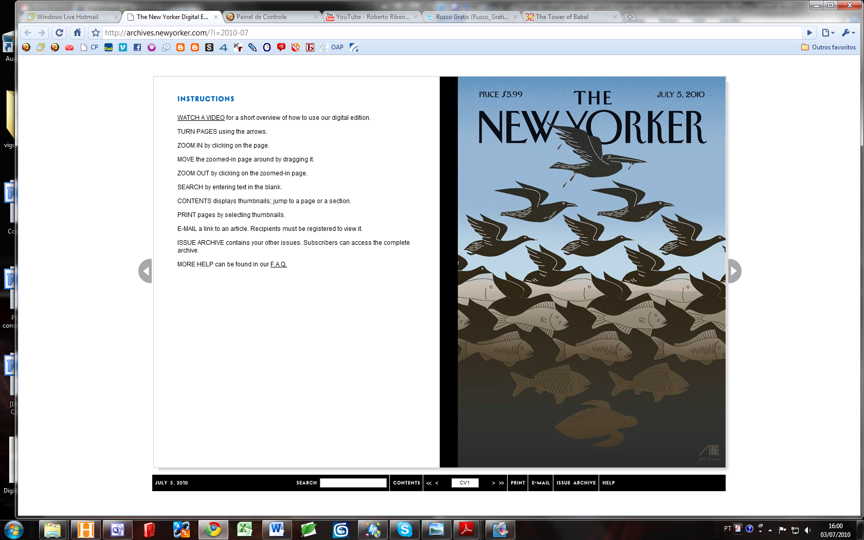
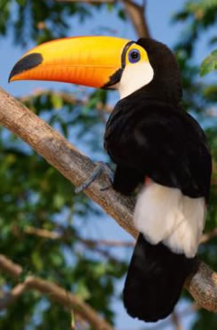
The first impression that I have is that I had seen exactly the same picture before... But just after my tendency is to try understanding some conceptual possible meanings… For instance I see this reflect some evolution concept… The lower being in the darkest position is a turtle - it is very old and very low… Then we have some fishes, they are faster but they are arrested in their water environment… The birds are even faster, and they can fly in the sky and take food in water… of course the own fishes can be food for the birs but not vice versa – then we can see evolutionary lines… I don’t now but the higher bird the pelican (is this the word in English? The higher bird have a big --- This is the top of evolution because it can save more food and have more flying autonomy, can late more before return to the water take more food… Metaphorically I understand that the image play background <-> foreground can suggest that the higher is present since the lowest… The birds are in germen since the meddle of evolution… Other impressing thing for me, not so conceptual, but affective, is that the lowest form of life and the highest are both alone…. But, I don´t know about this animal as symbols of political movements etc. In Brazil there is a political social-democrat party that have a “Tucano” has symbol… After all there is a Cartesian vetorial direction from left to right… as all the animals was going together to some kind of common (dark) future… I see that nobody is very happy in this image… Hum sure, this because all they are impregnate with oil – It’s only now that I see… This is a political critic to the environmental crimes!!! And I was more focused in structural symbolic questions internal of the sign-system functioning? Than with the more important problems for Human kind. I am shamed… ☺ Achilles, Umuarama, July, 03 – 2010…

